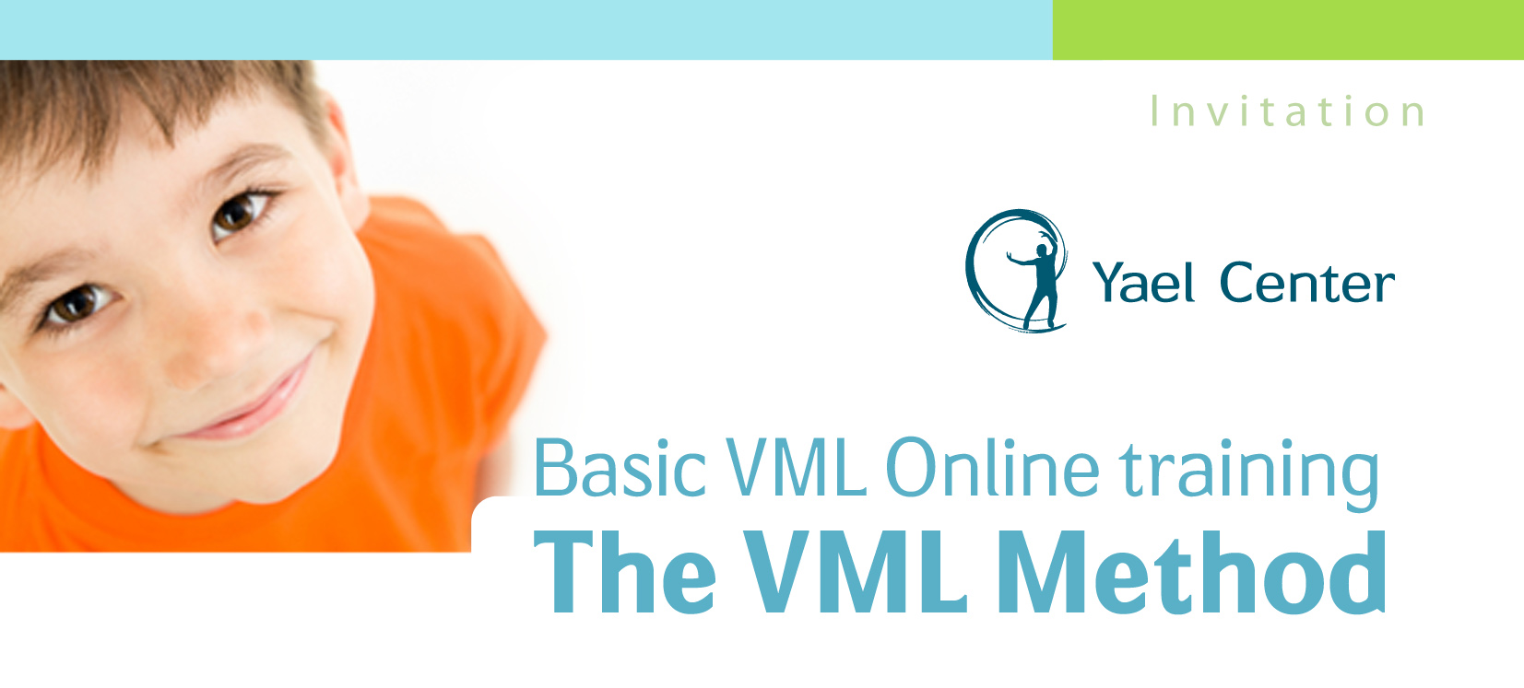The VML (Verbal Motor Learning) method is used for treating Childhood Apraxia of Speech (CAS). It was developed by Dr. Elad Vashdi from Israel over the last 18 years and has being practiced and learned in Israel and Australia.
The VML method uses manual techniques and motor learning principles in order to teach the child how to pronounce consonants, vowels, syllables and words. It also gives solutions to pre-verbal stages such as: oral-motor control, oral sensory condition, and breathing control.

The VML method treats the motor aspect of speech while using a multi-dimensional perspective and regarding all aspects of development.
The VML is a unique tool in the speech treatment field due to the amount of techniques involved in the method, well organized structure, multi-dimensional approach, cross-disciplinary knowledge, 19 years of experience and evidence of results based on many years of treatment. Over 20 VML trainings where delivered in Hebrew and English.

The VML is research based method. Currently we perform a wide range of research protocols, targeting questions regarding CAS. Two articles were published so far in the professional literature and many more are in editing and research procedures. The VML was presented in international conferences and workshops around the world.

This training was developed in order to enable professionals and families in Australia to participate in this unique program and to get to more children with speech difficulties.

The VML training objectives are:
- The participant will learn of the VML method development and structure
- The participant will learn of the Latest CAS research results and implications
- The participant will learn to administer all the manual techniques
- The participant will learn to administer the VML Evaluation and basic analysis.
- The participant will learn to use motor learning principles in treatment.

Training structure

The training will take place in three stages:
- Online – theory
- Meetings – techniques and motor learning
- Distance learning – practice and analysis
Stage 1:
Date – October 2015.
Meetings - 4 online meetings (3 hours each), Friday Morning.
Topics- The VML method ; Apraxia of speech ; anatomy and physiology of speech

Stage 2:
Dates – November 2015 on Fridays
Meetings – 8 hours per day. 8:30am – 4:30pm.
Topics – manual techniques ; motor learning principles

Stage 3:
Date - Dec 2015 – June 2016
Meetings – 10 online meetings, once every 3 weeks for 2 hours. Friday morning.
Topics – evaluation ; case analysis ; treatment planning.
Practical training (PT) –40 hours Observation of treatment. (10-20 sessions)
PT requirements:
Summaries of 20 observation topics.

Target population: SLP, health care providers, PT, OT, Parents.
Requirements:
- Two years of experience in working with children with speech delay.
- Compatible CV
- 80% participation in lectures
- 4 assignments for non-SLP participants (not parents)
- The course will be delivered in Hebrew.
Registration
Online registration is available at http://freeonlinesurveys.com/s.asp?sid=1duuqvmu348a7mn512090

Training fee
5000 nis - (credit, cash). Terms of payment will determine after registration.
Training value

- VML Therapist Certificate
- Basic knowledge of VML Manual Techniques
- The ability to start analyzing a case
- Basic knowledge in Motor Learning principles for CAS
- Affiliation to VML members group
- A Complete tool to treat CAS
For further information please contact Dr vashdi at:
center@yaelcenter.com
Tel (Israel) - +972523638340
Tel (Australia) - +61432293758

VML Training syllabus

Lesson | Date | Time | Topic | place
1 | 9/10/2015 | 1pm-4pm | VML method and CAS | Online
2 | 16/10/2015 | 1pm-4pm | Speech physiology and sensory motor pathways | Online
3 | 23/10/2015 | 1pm-4pm | Sensory motor aspect of speech development | Online
4 | 6/11/2015 | 1pm-4pm | Phonemes control parameters | Online
5 | 20/11/2015 | 9am-12:30pm | Pre verbal techniques + treatment structure | Herzlia
6 | 20/11/2015 | 1:30pm-4:30pm | Vowels and consonants techniques | Herzlia
7 | 27/11/2015 | 9am-12:30pm | Consonants techniques | Herzlia
8 | 27/11/2015 | 1:30pm-4:30pm | Consonants techniques and inter group techniques | Herzlia
9 | 4/12/2015 | 9am-12:30pm | Words forming techniques | Herzlia
10 | 4/12/2015 | 1:30pm-4:30pm | Motor learning principles | Herzlia
11 | 18/12/2015 | 1pm-4pm | Motor learning principles | Online
12 | 8/1/2016 | 1pm-4pm | Evaluation and analysis procedures | Online
13 | 15/1/2016 | 1pm-4pm | Case studies | Online
14 | 12/2/2016 | 1pm-4pm | Case studies | Online
15 | 26/2/2016 | 1pm-4pm | Case studies | Online
16 | 18/3/2016 | 1pm-4pm | Case studies | Online
17 | 1/4/2016 | 1pm-4pm | Forming treatment plan | Online
18 | 15/4/2016 | 1pm-4pm | Forming treatment plan | Online
19 | 6/5/2016 | 1pm-4pm | Forming treatment plan , final home exam | Online
20 | 27/5/2016 | 1pm-4pm | Forming treatment plan and summary | online

